IT Project Management Process Groups
According to the Project Management Institute PMBOK framework, project management consists of:
- Initiating
- Planning
- Executing
- Monitoring & Controlling
- Closing
For IT projects, Execution and Monitoring & Controlling consume most of the project effort and budget.
IT Project Execution Phase
- The Project Execution Phase is the stage in which the project team performs the work defined in the project management plan to produce the project's deliverables.
- It is the phase where plans are put into action and actual project work is carried out.
Example (IT Project)
Suppose a company is developing an Online Banking System.
- Planning Phase: Requirements, schedule, budget, and resources are planned.
- Execution Phase: Developers write code, testers test the application, infrastructure is configured, and the system is developed.
Objectives of Project Execution
- Produce project deliverables
- Manage project resources
- Implement approved changes
- Ensure quality standards
- Communicate with stakeholders
- Achieve project objectives
Inputs, Tools & Techniques, Outputs
Inputs | Tools & Techniques | Outputs
Project Management Plan | Expert Judgment | Deliverables
Project Documents | Project Management Information System (PMIS) | Work Performance Data
Approved Change Requests | Meetings | Issue Log Updates
Enterprise Environmental Factors | Interpersonal Skills | Change Requests
Organizational Process Assets | Leadership | Project Plan Updates
Key Activities During Execution
Major Activities in Project Execution
1. Direct and Manage Project Work
Perform the tasks defined in the project plan.
Example
- Coding software modules
- Configuring servers
- Creating databases
2. Manage Project Team
Assign tasks and coordinate team members.
Example
- Assign developers to modules
- Conduct team meetings
- Resolve team conflicts
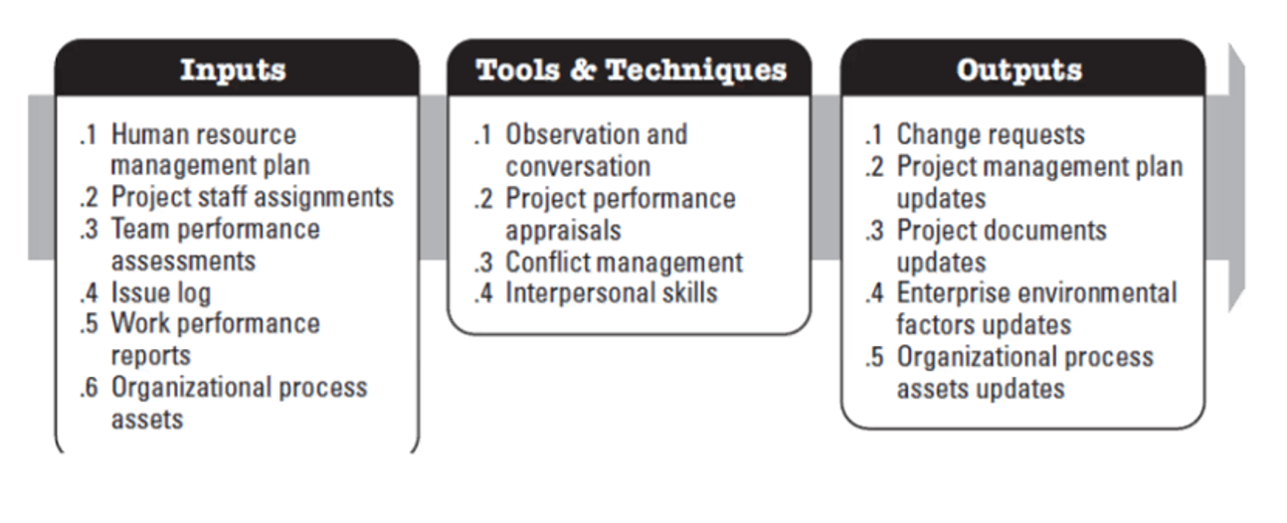
Manage Resources is the process of ensuring that project resources (people, equipment, materials, and facilities) are available, utilized effectively, and managed properly throughout the project.
In simple terms, it means leading, monitoring, motivating, and optimizing the use of project resources to achieve project objectives.
Purpose
The purpose of Manage Resources is to:
- Ensure resources are used efficiently
- Improve team performance
- Resolve conflicts
- Monitor resource utilization
- Enhance productivity
- Maintain a positive work environment
Example (IT Project)
Suppose a company is developing an E-Commerce Website.
Resources have already been acquired:
- 4 Developers
- 2 Testers
- 1 UI Designer
- Cloud Infrastructure
The Project Manager must now:
- Assign tasks
- Monitor workloads
- Resolve team conflicts
- Track performance
- Ensure resources are productive
These activities are part of Manage Resources.
Inputs, Tools & Techniques, Outputs (ITTO)
Inputs
Input | Description
Project Management Plan | Defines how resources will be managed
Project Documents | Resource requirements, team assignments
Team Charter | Defines team values and working agreements
Issue Log | Resource-related issues
Enterprise Environmental Factors (EEF) | Organizational culture and policies
Organizational Process Assets (OPA) | Templates and lessons learned
Example
The Resource Management Plan specifies:
- Reporting structure
- Roles and responsibilities
- Performance expectations
Tools & Techniques
1. Leadership
Guide and motivate team members.
Example
The Project Manager motivates developers to meet sprint goals.
2. Conflict Management
Resolve disagreements within the team.
Example
Two developers disagree on technology selection. The PM facilitates discussion and reaches a decision.
3. Problem Solving
Identify and resolve project issues.
Example
A server outage delays testing; the PM arranges alternative infrastructure.
4. Interpersonal and Team Skills
- Communication
- Negotiation
- Emotional Intelligence
- Influencing
Example
The PM negotiates resource sharing with another project manager.
5. Project Management Information System (PMIS)
Monitor resource utilization and performance.
Example
Using Jira, Azure DevOps, or MS Project to track assignments and progress.
Outputs
Output | Description
Change Requests | Requests for resource changes
Project Management Plan Updates | Updates to resource plans
Project Documents Updates | Updated issue logs and assignments
Enterprise Environmental Factor Updates | Improved organizational knowledge

Key Activities in Managing Resources
1. Assign and Coordinate Work
Ensure work is distributed appropriately.
Example
Team Member | Task
Developer A | User Authentication
Developer B | Payment Gateway
Tester A | Functional Testing
2. Monitor Resource Utilization
Track how resources are being used.
Example
A developer is overloaded while another has little work. The PM redistributes tasks.
3. Resolve Conflicts
Address disagreements quickly.
Example
Two teams need the same database server. The PM prioritizes usage and schedules access.
4. Motivate Team Members
Keep morale and engagement high.
Example
Recognizing a developer who successfully completed a critical module ahead of schedule.
5. Manage Team Performance
Evaluate productivity and identify improvement opportunities.
Example
Reviewing sprint velocity and code quality metrics.
6. Address Resource Issues
Handle absences, turnover, and skill gaps.
Example
A key developer resigns; the PM arranges knowledge transfer and replacement.
Example Scenario
Project
Hospital Management System
Acquired Resources
- 5 Developers
- 2 Testers
- 1 Business Analyst
- Cloud Environment
Resource Management Activities
- Conduct daily stand-up meetings
- Monitor workload distribution
- Resolve conflicts
- Track productivity
- Provide coaching and support
Outputs
- Improved collaboration
- Balanced workloads
- Higher productivity
- Reduced project delays
Common Resource Management Challenges
- Resource Overallocation
- One person assigned too many tasks.
- Resource Underutilization
- Resources remain idle.
- Team Conflicts
- Disagreements affect productivity.
- Skill Gaps
- Team lacks required expertise.
- Employee Turnover
- Key resources leave the project.

Difference Between Acquire Resources and Manage Resources
Acquire Resources | Manage Resources
Obtain resources for the project | Utilize and control resources effectively
Focuses on staffing and procurement | Focuses on performance and productivity
Done when resources are needed | Continues throughout project execution
Example: Hiring developers | Example: Managing developers' workload
Summary
Aspect | Description
Process | Manage Resources
Process Group | Executing
Purpose | Ensure resources are used effectively and efficiently
Key Inputs | Resource Management Plan, Team Charter, Issue Log
Key Tools | Leadership, Conflict Management, Problem Solving, PMIS
Key Outputs | Change Requests, Plan Updates, Improved Team Performance
Example | Assigning work, monitoring workloads, resolving conflicts
One-Line Definition
Manage Resources is the PMBOK process of leading, monitoring, and optimizing project resources to improve performance and successfully achieve project objectives.

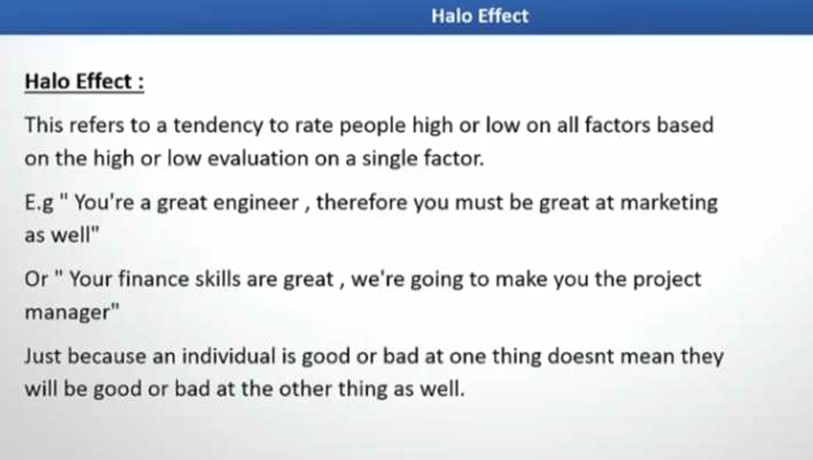
3. Acquire Resources
Obtain required people, hardware, software, and services.
Example
- Hire a Java Developer
- Purchase cloud hosting services
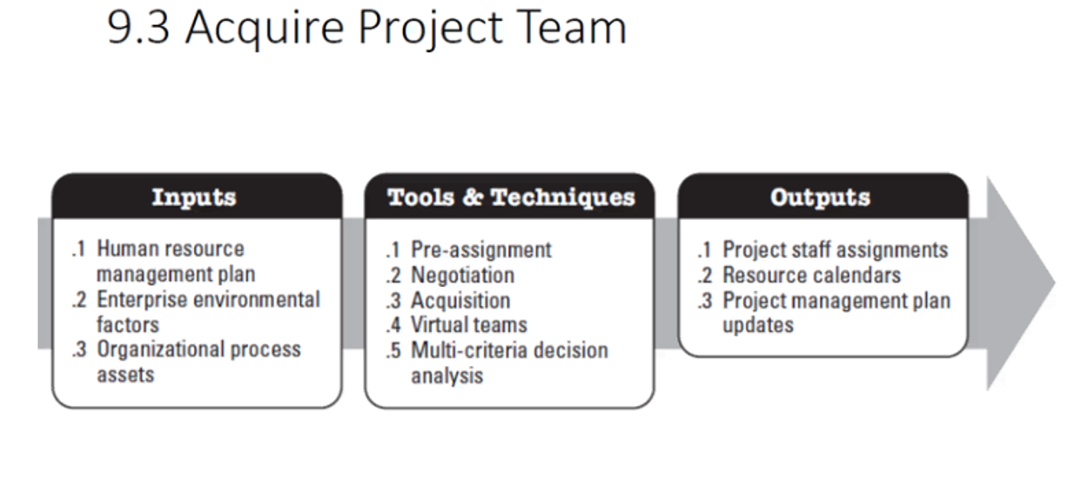
Acquire Resources (PMBOK)
What is Acquire Resources?
Acquire Resources is the process of obtaining the team members, facilities, equipment, materials, and other resources needed to complete project work.
In simple terms, it means getting the right people and resources at the right time for the project.
Purpose
The purpose of Acquire Resources is to:
- Ensure the project has sufficient resources
- Assign qualified team members
- Obtain necessary hardware, software, and facilities
- Support project execution and delivery
Example (IT Project)
Suppose a company is developing a Hospital Management System.
The Project Manager identifies the need for:
- 4 Software Developers
- 2 Test Engineers
- 1 UI/UX Designer
- Cloud Server
- Software Licenses
The process of obtaining these resources is called Acquire Resources.
Inputs, Tools & Techniques, Outputs (ITTO)
Inputs
Input | Description
Project Management Plan | Defines resource requirements
Project Documents | Resource needs, schedules, risk register
Enterprise Environmental Factors (EEF) | Organizational structure, labor market
Organizational Process Assets (OPA) | Policies, procedures, historical data
Example
A project plan indicates:
- Need for 5 developers
- AWS cloud environment
- Database administrator
These become inputs for acquiring resources.
Tools & Techniques
1. Pre-assignment
Resources are assigned before the project starts.
Example
A client specifically requests a senior architect for the project.
2. Negotiation
Discuss resource allocation with managers or vendors.
Example
The Project Manager negotiates with the IT department to assign two experienced developers.
3. Acquisition
Acquire resources from outside the organization.
Example
Hiring a cybersecurity consultant on contract.
4. Virtual Teams
Use geographically distributed team members.
Example
Developers work from Nepal, India, and the USA on the same project.
5. Multi-Criteria Decision Analysis
Select resources based on multiple factors.
Example
Choosing a developer based on:
- Skills
- Experience
- Availability
- Cost
Outputs
Output | Description
Physical Resource Assignments | Equipment, facilities, tools assigned
Project Team Assignments | Team members assigned
Resource Calendars | Availability schedules
Change Requests | Additional resources may be requested
Project Management Plan Updates | Resource plans updated
Project Documents Updates | Resource records updated
Resource Acquisition Process
Step 1: Identify Resource Requirements
Determine what resources are needed.
Example
- 3 Java Developers
- 1 Tester
- 1 Business Analyst
Step 2: Check Resource Availability
Determine whether resources are available internally.
Example
The organization already has 2 Java Developers available.
Step 3: Acquire Remaining Resources
Hire or procure additional resources.
Example
Hire one additional Java Developer through a recruitment agency.
Step 4: Assign Resources
Allocate resources to project activities.
Example
- Developer A → User Management Module
- Developer B → Payment Module
- Tester → System Testing
Step 5: Update Resource Calendar
Record when resources are available.
Example
Developer A available from July 1 to December 31.
Example Scenario
Project
Online Banking System
Resource Requirements
Resource | Quantity
Java Developer | 4
Tester | 2
DevOps Engineer | 1
AWS Server | 2
Database Administrator | 1
Activities
- Negotiate with department managers
- Hire contract developers
- Procure cloud servers
- Assign team members
Outputs
- Project team formed
- Servers provisioned
- Resource calendar updated
- Project work begins
Challenges in Acquiring Resources
- Resource Shortage
- Needed skills may not be available.
- Resource Conflicts
- The same person may be assigned to multiple projects.
- Budget Constraints
- Limited budget may restrict hiring.
- Skill Gaps
- Available resources may require training.
Summary
Aspect | Description
Process | Acquire Resources
Process Group | Executing
Purpose | Obtain people, equipment, facilities, and materials needed for the project
Key Inputs | Project Management Plan, Project Documents, EEF, OPA
Key Tools | Pre-assignment, Negotiation, Acquisition, Virtual Teams
Key Outputs | Team Assignments, Resource Calendars, Resource Assignments
Example | Hiring developers, assigning testers, procuring cloud servers
One-Line Definition
Acquire Resources is the PMBOK process of obtaining and assigning the people, equipment, facilities, and materials required to successfully execute a project.

4. Develop Team
Improve team skills through training and coaching.
Example
- Agile training
- AI certification programs
- Technical workshops
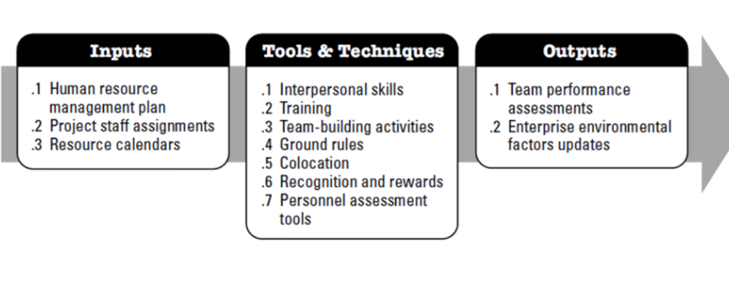
Team Development Stages (Tuckman's Model)
Bruce Tuckman proposed that teams typically go through five stages of development:
- Forming
- Storming
- Norming
- Performing
- Adjourning
Understanding these stages helps project managers build effective teams and resolve issues.
1. Forming Stage
What Happens?
The team is newly created. Members are getting to know each other and understanding the project's goals, roles, and expectations.
Characteristics
- Excitement and enthusiasm
- Uncertainty about responsibilities
- Dependence on the project manager
- Polite interactions
Project Manager's Role
- Provide clear direction
- Explain project objectives
- Define roles and responsibilities
Example
A company starts a mobile banking application project. Developers, testers, business analysts, and UI designers meet for the first time. Team members introduce themselves and learn about the project.
2. Storming Stage
What Happens?
Conflicts and disagreements begin to appear as team members express different opinions and working styles.
Characteristics
- Arguments and disagreements
- Competition among members
- Resistance to authority or processes
- Frustration and tension
Project Manager's Role
- Resolve conflicts
- Encourage communication
- Clarify expectations
- Build trust
Example
A developer wants to use React while another prefers Angular. Testers complain that requirements are unclear. Team members disagree on technical approaches.
3. Norming Stage
What Happens?
The team starts working together effectively. Members understand their roles and establish common working practices.
Characteristics
- Improved cooperation
- Better communication
- Mutual trust develops
- Team rules are accepted
Project Manager's Role
- Encourage collaboration
- Support teamwork
- Recognize achievements
Example
The team agrees on coding standards, sprint ceremonies, communication channels, and issue-tracking processes. Members begin helping each other solve problems.
4. Performing Stage
What Happens?
The team reaches peak productivity and works efficiently toward project goals.
Characteristics
- High trust and collaboration
- Minimal supervision required
- Strong problem-solving ability
- High productivity
Project Manager's Role
- Empower the team
- Remove obstacles
- Focus on strategic issues
Example
The Agile team delivers features every sprint, resolves issues quickly, and consistently meets deadlines with high-quality output.
5. Adjourning Stage
What Happens?
The project is completed, and the team is disbanded or reassigned.
Characteristics
- Project closure activities
- Knowledge transfer
- Celebration of success
- Team members move to new projects
Project Manager's Role
- Conduct lessons learned
- Recognize contributions
- Ensure proper project closure
Example
After successfully launching the banking application, the team conducts a project review meeting, documents lessons learned, and members move to different projects.
Summary Table
Stage | Key Characteristics | Project Manager's Focus
Forming | Team members meet and learn about project | Provide direction and clarity
Storming | Conflicts and disagreements arise | Resolve conflicts and build trust
Norming | Team develops cooperation and standards | Encourage collaboration
Performing | High productivity and independence | Empower team and remove obstacles
Adjourning | Project completion and team dissolution | Close project and capture lessons learned
Simple Example
Imagine a team developing an e-commerce website:
- Forming: Team members meet and discuss project goals.
- Storming: Disagreements occur about technology choices.
- Norming: Team agrees on processes and standards.
- Performing: Team delivers features efficiently and meets deadlines.
- Adjourning: Website launches successfully, and the team is released.
Memory Tip:
F → S → N → P → A
Forming → Storming → Norming → Performing → Adjourning
"First Some New Projects Arrive" can help you remember the sequence

5. Manage Communications
Share project information with stakeholders.
Example
- Weekly status reports
- Sprint review meetings
- Client demonstrations
6. Manage Quality
Ensure deliverables meet quality standards.
Example
- Code reviews
- Unit testing
- Security testing
7. Manage Stakeholder Engagement
Maintain stakeholder involvement and satisfaction.
Example
- Gather user feedback
- Conduct product demonstrations

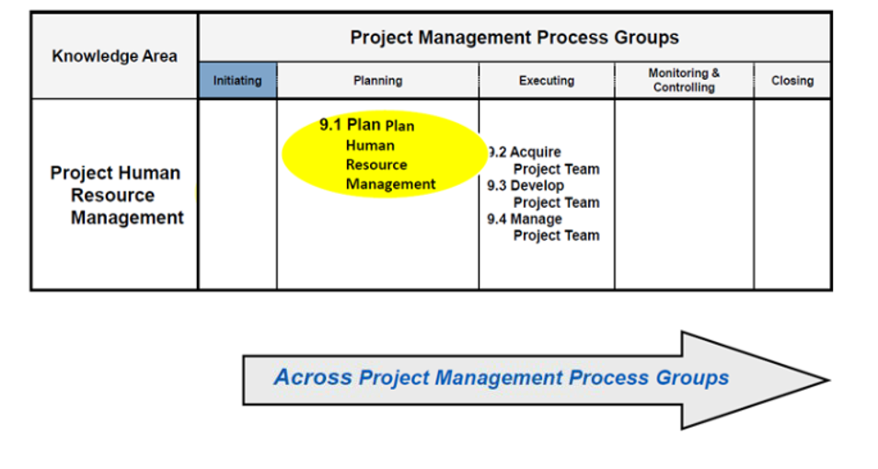
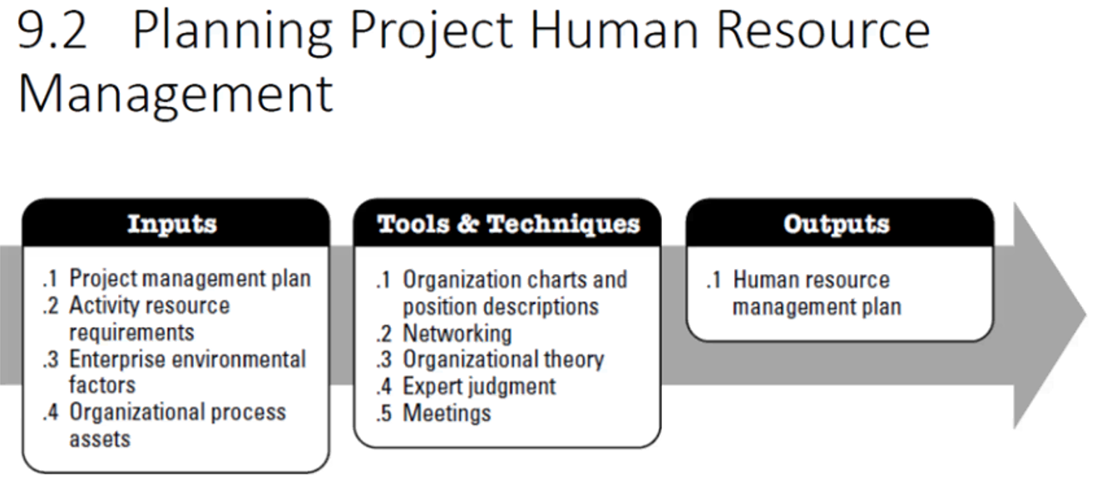
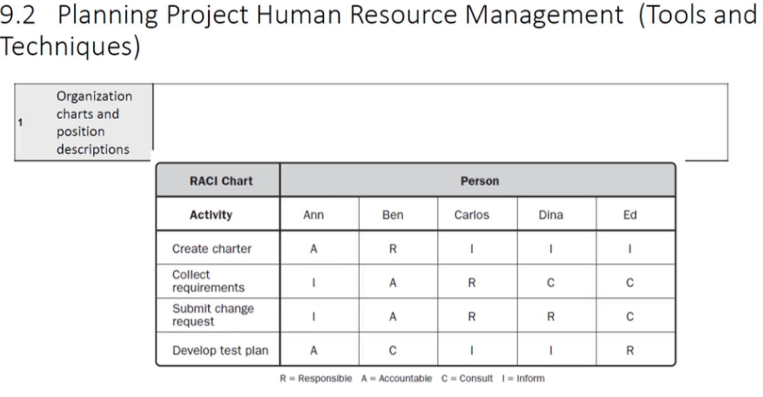

Inputs, Tools & Techniques, Outputs (ITTO)
Inputs
Inputs are resources and information needed to start execution.
Input | Description
Project Management Plan | Approved roadmap for execution
Project Documents | Requirements, schedules, risk register, etc.
Approved Change Requests | Changes authorized for implementation
Enterprise Environmental Factors (EEF) | Organizational culture, tools, infrastructure
Organizational Process Assets (OPA) | Templates, guidelines, lessons learned
Example
For an ERP implementation project:
- Project Plan specifies 6-month schedule.
- Risk Register identifies data migration risks.
- Approved Change Request adds a reporting module.
Tools & Techniques
Tool/Technique | Purpose
Expert Judgment | Obtain guidance from specialists
Meetings | Coordinate work and decisions
Project Management Information System (PMIS) | Track project activities
Leadership Skills | Guide team performance
Communication Skills | Share project information
Conflict Management | Resolve team issues
Example
A Project Manager conducts:
- Daily Scrum meetings
- Weekly status reviews
- Risk review meetings
Outputs
Outputs are the results produced during execution.
Output | Description
Deliverables | Products or services created
Work Performance Data | Raw performance information
Issue Log Updates | Newly identified issues
Change Requests | Requests for modifications
Project Plan Updates | Revisions to project plans
Project Document Updates | Updated project records
Example: IT Project Execution
Project
Online Shopping Application
Inputs
- Approved Project Plan
- Requirement Specification
- Budget: $100,000
- Development Team
Activities
- Design user interface
- Develop application
- Perform testing
- Conduct review meetings
- Manage team members
Outputs
- Working e-commerce application
- Test reports
- Progress reports
- Change requests
- Updated project documents

Monitoring & Controlling Phase
Purpose
Track project performance and compare actual results against planned results.
Questions answered:
- Are we on schedule?
- Are we within budget?
- Are risks increasing?
- Is quality acceptable?
- Do changes need approval?
Inputs, Tools & Techniques, Outputs
Inputs | Tools & Techniques | Outputs
Project Management Plan | Variance Analysis | Work Performance Reports
Work Performance Data | Trend Analysis | Change Requests
Project Documents | Earned Value Management | Forecasts
Agreements | Root Cause Analysis | Corrective Actions
Enterprise Environmental Factors | Meetings | Updated Project Documents
Major Monitoring Activities
Schedule Monitoring
Compare:
- Planned progress
- Actual progress
Example:
Planned completion = 60%
Actual completion = 45%
Schedule variance exists.
Cost Monitoring
Compare:
- Budgeted cost
- Actual cost
Example:
Budget = $100,000
Actual spent = $120,000
Cost overrun = $20,000
Quality Monitoring
Check:
- Defect rates
- Test coverage
- User acceptance results
Risk Monitoring
Track:
- Open risks
- New risks
- Risk response effectiveness
Team Management in IT Projects
Functional Team
People belong to departments.
Example:
- Development Department
- Testing Department
- Infrastructure Department
Advantages:
- Technical expertise
Disadvantages:
- Slow communication
Matrix Team
Employees report to:
- Functional Manager
- Project Manager
Types:
Weak Matrix
Functional manager has more authority.
Balanced Matrix
Authority shared.
Strong Matrix
Project manager has more authority.
Projectized Team
Resources dedicated entirely to project.
Advantages:
- Faster decisions
- Better coordination
Disadvantages:
- Resource duplication
Agile / Cross-functional Team
Common in modern IT projects.
Includes:
- Developers
- Testers
- UX Designers
- Business Analysts
- DevOps Engineers
Advantages:
- Fast delivery
- Better collaboration
Tracking Project Progress
A. Earned Value Management (EVM)
Measures:
- Scope
- Schedule
- Cost
Together.
Key Metrics
Planned Value (PV)
Budgeted value of work planned.
Example:
Planned work = $50,000
PV = $50,000
Earned Value (EV)
Budgeted value of work completed.
Example:
40% complete of $100,000 project
EV = $40,000
Actual Cost (AC)
Actual money spent.
Example:
AC = $45,000
Schedule Variance (SV)
SV = EV − PV
Example:
40,000 − 50,000
SV = -10,000
Project is behind schedule.
Cost Variance (CV)
CV = EV − AC
40,000 − 45,000
CV = -5,000
Project is over budget.
Schedule Performance Index (SPI)
SPI = EV / PV
40,000 / 50,000 = 0.8
SPI < 1 → Behind Schedule
Cost Performance Index (CPI)
CPI = EV / AC
40,000 / 45,000 = 0.89
CPI < 1 → Over Budget
EVM Interpretation
EVM performance interpretation
Quick interpretation of common EVM indicators.
00.81.62.43.2SPI < 1SPI = 1SPI > 1CPI < 1CPI = 1CPI > 1
- SPI < 1 = Behind Schedule
- SPI > 1 = Ahead of Schedule
- CPI < 1 = Over Budget
- CPI > 1 = Under Budget
B. Burn Down Chart
Used in Agile projects.
Tracks:
- Remaining work
- Time remaining
Example:
Sprint Day | Remaining Story Points
Day 1 | 100
Day 3 | 75
Day 5 | 55
Day 8 | 30
Day 10 | 0
Benefits:
- Shows sprint progress
- Predicts completion
- Identifies delays early
C. Velocity
Measures completed story points per sprint.
Example:
Sprint | Velocity
Sprint 1 | 25
Sprint 2 | 30
Sprint 3 | 28
Average Velocity = 28
Used for release planning.
D. Throughput
Number of completed work items per period.
Example:
- Week 1 = 12 tickets
- Week 2 = 15 tickets
Useful in Kanban environments.
E. Cycle Time
Time from work start to completion.
Example:
Task started: June 1
Completed: June 6
Cycle Time = 5 days

6. Controlling Project Progress
Purpose:
Take corrective action when project deviates from plan.
Control Techniques
Corrective Action
Fix current issue.
Example:
Add developers to recover schedule.
Preventive Action
Avoid future issue.
Example:
Increase automated testing.
Defect Repair
Fix identified defects.
Example:
Bug fixing before release.
Replanning
Update baseline when approved.
Example:
New feature added.
Schedule revised.
7. Change Management
Definition
Formal process used to evaluate, approve, reject, and implement project changes.
Without change control:
- Scope creep
- Budget overrun
- Schedule delays
occur frequently.
8. Change Management Process
Step 1: Raise Change Request
Example:
Client requests AI-powered chatbot feature.
Step 2: Log Change Request
Record:
- Description
- Requestor
- Date
- Priority
Step 3: Impact Analysis
Analyze impact on:
- Scope
- Cost
- Schedule
- Resources
- Risks
- Quality
Example:
Additional effort = 120 hours
Cost increase = $8,000
Schedule impact = 2 weeks
Step 4: Review by Change Control Board (CCB)
CCB evaluates:
- Business value
- Risk
- Cost-benefit
Step 5: Decision
- Approved
- Rejected
- Deferred
Step 6: Update Baselines
If approved:
- Scope baseline
- Schedule baseline
- Cost baseline
are updated.
Step 7: Implement Change
Development team executes change.
Step 8: Verify and Close
Confirm:
- Change implemented
- Requirements satisfied
- Documentation updated
Conflict Management in Project Management
What is Conflict?
A conflict is a disagreement or difference of opinion between individuals or groups regarding goals, priorities, resources, processes, or solutions.
Example
In an IT project:
- Developer A wants to use React.
- Developer B wants to use Angular.
This disagreement is a conflict.
Is Conflict Always Wrong?
No.
PMBOK recognizes that conflict can be positive (constructive) or negative (destructive).
Positive Conflict
Leads to:
- Better ideas
- Innovation
- Problem solving
- Improved decisions
Example
Two architects debate different database designs. After discussion, they choose a more scalable solution.
Negative Conflict
Leads to:
- Delays
- Poor morale
- Reduced productivity
- Team divisions
Example
Team members stop communicating because of personal disagreements.
Why Does Conflict Need to Be Managed?
Conflicts are natural in projects because:
- Resources are limited
- Deadlines are tight
- Team members have different skills and backgrounds
- Stakeholders have competing priorities
If conflicts are not managed:
- Productivity decreases
- Team morale suffers
- Project delays occur
- Quality declines
The goal is not to eliminate conflict, but to manage it constructively.
Conflict Management Approaches (PMBOK)
1. Collaborating (Problem Solving / Win-Win)
Definition
Both parties work together to find a solution that satisfies everyone.
Characteristics
- Addresses root cause
- High cooperation
- Long-term solution
- Best technique when time permits
Example
Developer A wants React.
Developer B wants Angular.
The team evaluates:
- Skills
- Project requirements
- Performance
- Support
After analysis, they choose the best technology for the project.
Result
✔ Both parties feel heard.
✔ Best solution found.
When to Use
- Important issue
- Long-term relationships matter
- Time available for discussion
2. Compromising (Give and Take)
Definition
Each party gives up something to reach a mutually acceptable solution.
Characteristics
- Moderate satisfaction
- Quick resolution
- Temporary solution
Example
Two departments need the same server.
Agreement:
- Team A uses it in the morning.
- Team B uses it in the afternoon.
Result
✔ Both gain something.
✖ Neither gets everything.
When to Use
- Limited time
- Equal power among parties
- Temporary solution needed
3. Forcing (Directing / Win-Lose)
Definition
One party imposes a solution using authority or power.
Characteristics
- Fast decision
- One side wins
- Other side loses
- May create resentment
Example
A project is behind schedule.
The Project Manager decides:
"We will use React. Discussion closed."
Result
✔ Quick resolution.
✖ Team may feel ignored.
When to Use
- Emergency situations
- Safety or compliance issues
- Immediate action required
4. Avoiding (Withdraw / Retreat)
Definition
The conflict is postponed or ignored.
Characteristics
- No immediate resolution
- Useful for minor issues
- May allow emotions to cool down
Example
Two team members argue during a stressful release week.
The PM postpones the discussion until after deployment.
Result
✔ Immediate tension reduced.
✖ Problem remains unresolved.
When to Use
- Issue is minor
- More information is needed
- Better timing required
5. Smoothing (Accommodating)
Definition
Focus on areas of agreement while downplaying differences.
Characteristics
- Maintains harmony
- Preserves relationships
- Does not address root cause
Example
A developer and tester disagree about defect severity.
The PM says:
"We all want a successful release. Let's focus on that common goal."
The discussion is softened and the team moves forward.
Result
✔ Maintains good relationships.
✖ Root issue may still exist.
When to Use
- Relationship is more important than the issue
- Temporary harmony is needed
Comparison Table
Approach | Outcome | Best For | Example
Collaborating | Win-Win | Important issues and long-term solutions | Jointly selecting the best technology
Compromising | Partial Win-Win | Quick agreement | Sharing a server between teams
Forcing | Win-Lose | Emergencies and urgent decisions | PM mandates a technology choice
Avoiding | No Immediate Resolution | Minor issues or cooling-off period | Postponing an argument until later
Smoothing | Harmony Maintained | Relationship preservation | Focusing on common project goals
Example: Same Conflict, Different Approaches
Conflict: Developer A wants React; Developer B wants Angular.
Approach | What Happens?
Collaborating | Analyze requirements and choose the best option together
Compromising | Use React for one module and Angular for another
Forcing | PM selects React and ends the discussion
Avoiding | Decision postponed until next week
Smoothing | PM emphasizes shared project goals and reduces tension
Earned Value Management (EVM)
What is Earned Value Management?
Earned Value Management (EVM) is a project performance measurement technique that integrates:
- Scope
- Schedule
- Cost
to determine whether a project is progressing as planned.
It helps answer:
- Are we ahead or behind schedule?
- Are we under or over budget?
- How much work has actually been completed?
- What will the project likely cost when finished?
Basic EVM Metrics
Assume a project has:
- Total Budget (BAC) = $100,000
- Planned completion by today = 50%
- Actual completion by today = 40%
- Actual money spent = $45,000
1. Planned Value (PV)
Definition
The budgeted value of work that should have been completed by a certain date.
Formula
$$PV=Planned \% Completion×BAC$$
Example
Planned completion = 50%
BAC = $100,000
$$PV=50\%×100,000=\$50,000$$
Interpretation: By today, the project was supposed to complete $50,000 worth of work.
2. Earned Value (EV)
Definition
The budgeted value of work actually completed.
Formula
$$EV=Actual \% Completion×BAC$$
Example
Actual completion = 40%
BAC = $100,000
$$EV=40\%×100,000=\$40,000$$
Interpretation: The project has actually completed $40,000 worth of planned work.
3. Actual Cost (AC)
Definition
The actual money spent on the completed work.
Formula
$$AC=Actual Cost Incurred$$
Example
Actual spending = $45,000
$$AC=\$45,000$$
Schedule Performance Formulas
4. Schedule Variance (SV)
Definition
Difference between earned work and planned work.
Formula
$$SV=EV-PV$$
Example
EV = $40,000
PV = $50,000
$$SV=40,000-50,000=-10,000$$
Interpretation
- SV > 0 → Ahead of schedule
- SV = 0 → On schedule
- SV < 0 → Behind schedule
Result:
SV = -$10,000
Project is behind schedule.
5. Schedule Performance Index (SPI)
Definition
Measures schedule efficiency.
Formula
$$SPI=\frac{EV}{PV}$$
Example
$$SPI=\frac{40,000}{50,000} \\ SPI=0.8$$
Interpretation
- SPI > 1 → Ahead of schedule
- SPI = 1 → On schedule
- SPI < 1 → Behind schedule
Result:
SPI = 0.8
The project earns only 80 cents of planned work for every $1 of scheduled work.
Cost Performance Formulas
6. Cost Variance (CV)
Definition
Difference between earned value and actual spending.
Formula
$$CV=EV-AC$$
Example
$$CV=40,000-45,000 \\ CV=-5,000$$
Interpretation
- CV > 0 → Under budget
- CV = 0 → On budget
- CV < 0 → Over budget
Result:
CV = -$5,000
Project is over budget.
7. Cost Performance Index (CPI)
Definition
Measures cost efficiency.
Formula
$$CPI=\frac{EV}{AC}$$
Example
$$CPI=\frac{40,000}{45,000} \\ CPI=0.89$$
Interpretation
- CPI > 1 → Under budget
- CPI = 1 → On budget
- CPI < 1 → Over budget
Result:
CPI = 0.89
For every $1 spent, only $0.89 worth of work is earned.
Forecasting Formulas

8. Budget at Completion (BAC)
Definition
Total approved project budget.
Formula
$$BAC=Total Planned Budget$$
Example
$$BAC=\$100,000$$
9. Estimate at Completion (EAC)
Definition
Expected total project cost when completed.
Common Formula
$$EAC=\frac{BAC}{CPI}$$
Example
$$EAC=\frac{100,000}{0.89} \\ EAC=\$112,360$$
Interpretation
The project is expected to finish at approximately $112,360.
10. Estimate to Complete (ETC)
Definition
Expected additional cost required to finish the remaining work.
Formula
$$ETC=EAC-AC$$
Example
$$ETC=112,360-45,000 \\ ETC=\$67,360$$
Interpretation
Need another $67,360 to complete the project.
11. Variance at Completion (VAC)
Definition
Expected budget surplus or deficit at project completion.
Formula
$$VAC=BAC-EAC$$
Example
$$VAC=100,000-112,360 \\ VAC=-12,360$$
Interpretation
Project is expected to exceed budget by $12,360.
Complete Example Summary
Given:
- BAC = $100,000
- PV = $50,000
- EV = $40,000
- AC = $45,000
Metric | Formula | Result | Meaning
PV | Planned % × BAC | $50,000 | Planned work
EV | Actual % × BAC | $40,000 | Earned work
AC | Actual cost | $45,000 | Money spent
SV | EV − PV | -$10,000 | Behind schedule
SPI | EV ÷ PV | 0.80 | Schedule inefficient
CV | EV − AC | -$5,000 | Over budget
CPI | EV ÷ AC | 0.89 | Cost inefficient
BAC | Total budget | $100,000 | Approved budget
EAC | BAC ÷ CPI | $112,360 | Expected final cost
ETC | EAC − AC | $67,360 | Cost to finish
VAC | BAC − EAC | -$12,360 | Expected budget overrun
Quick Interpretation
Metric | Good | Bad
SV | Positive | Negative
SPI | > 1 | < 1
CV | Positive | Negative
CPI | > 1 | < 1
VAC | Positive | Negative
Positive variance is good. Negative variance is bad.
Index greater than 1 is good. Index less than 1 is bad.

